NAME: TEJAS NALAWADE PRACTICAL NO: 9 ROLL NO: TCOD01
AIM: MongoDB Queries Design and Develop MongoDB Queries using CRUD operations.
1. Collection "orderinfo" which contains the documents given as below
{
cust_id:123
cust_name:"abc",
status:"A",
price:250
}
i. find the average price for each customers having status 'A'
ii. Display the status of the customers whose amount/price lie between 100 and 1000
iii. Display the customers information without "_id".
iv. create a simple index on onderinfo collection and fire the queries.

2. Collection "movies" which contains the documents given as below
{
name: "Movie1",
type: "action",
budget:1000000
producer: {
name: "producer1",
address:"PUNE"
} }
i. Find the name of the movie having budget greater than 1,00,000.
ii. Find the name of producer who lives in Pune
iii. Update the type of movie "action" to "horror"
iv. Find all the documents produced by name "producer1" with their address

DATABASE AND COLLECTION

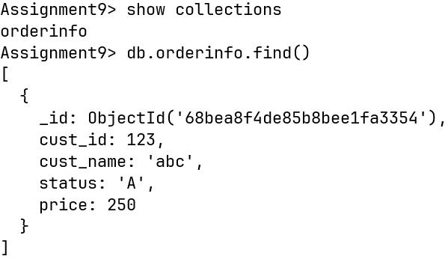

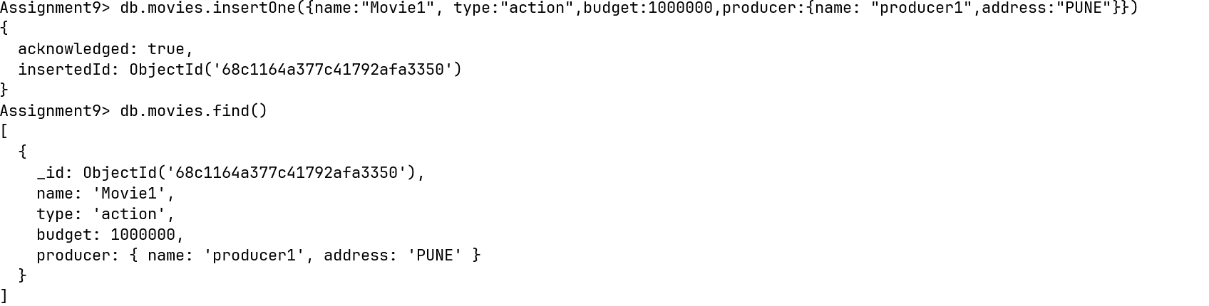

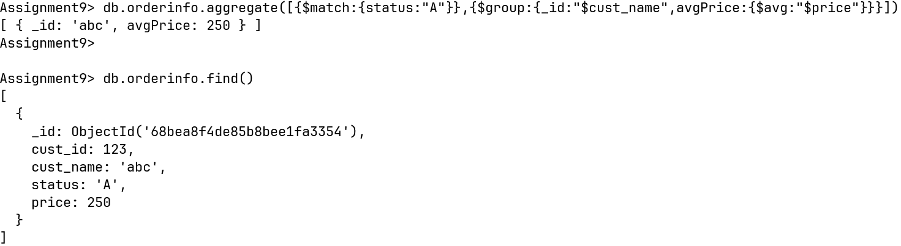
1) i)

1) ii)
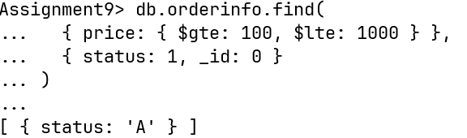

1)

iii and iv

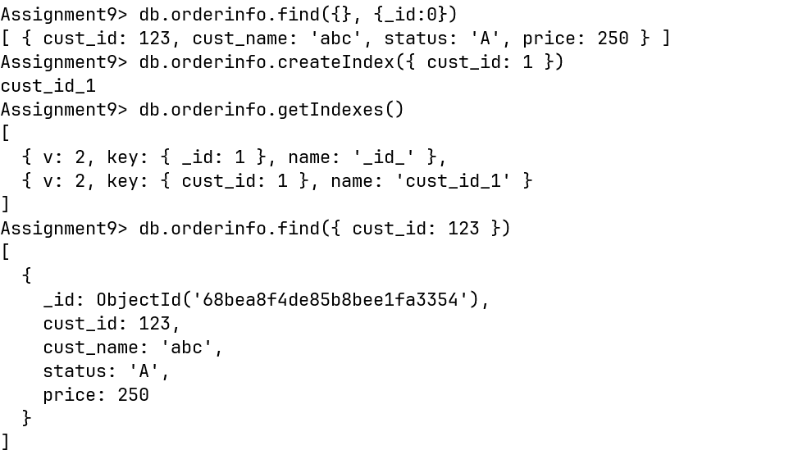

2)

i and ii
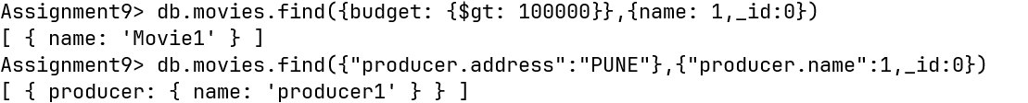

2)

iii and iv
